Simplify multi-step projects with prompt chaining
Some projects are too big to be completed all at once—multi-part work often comes together one step at a time. When working with generative AI tools, some challenges are best overcome by breaking them up into smaller, interconnected tasks, and with prompt chaining, you'll do just that. And taking it step by step also maintains the human-in-the-loop approach, so you can evaluate your prompts and results as you continue chaining them together to spot hallucinations.
Prompt chaining
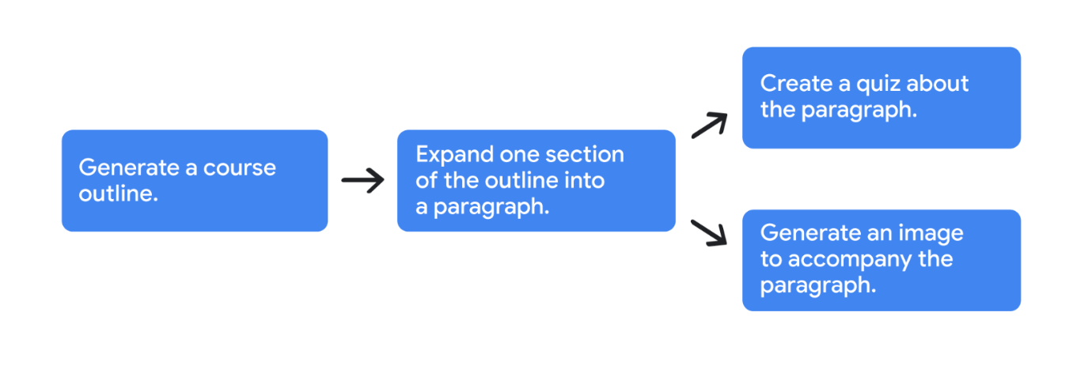
Sometimes, for more complex tasks, it can help to take the output of a gen AI tool and use it as context for a new prompt. Connecting prompts is like connecting links in a chain—which is why this process is called prompt chaining.
A great prompt chain is only as strong as the prompts within it, and specificity is the secret to success. Here’s an example: You’re the head of human resources for an advertising agency, and you’ve been tasked with designing an onboarding course for new hires. Creating a program from scratch involves a lot of moving parts, so you’re going to use prompt chaining to keep the workload manageable.
Here’s an example input:
I’m the head of human resources for an advertising agency, and I’m designing an onboarding course for new hires. Generate an outline specifying the most important parts of an onboarding course for an entry-level hire.
And here’s an example of the potential output from that prompt:
Onboarding Course Outline for Entry-Level Hires at an Advertising Agency
- Introduce agency culture and values
- Summarize duties and responsibilities
- Explain advertising industry fundamentals
- Break down agency tools and technology
- Detail client relationships and communication practices
- Review agency policies and procedures
- Encourage professional development and growth
Having that output as a foundation then allows the gen AI tool to carry out all sorts of related assignments. For the next part of the prompt chain, you’ll follow up on the second bullet, and expand on the expectations for a new addition to the design department. But keep in mind, some gen AI models don’t automatically retain context from one prompt to the next, and may require you to re-enter the relevant information into the prompt yourself.
Here’s an example input:
Expand the second bullet point from the attached outline into a paragraph of 100 words, including expectations for their first year.
And here’s what that output might look like:
As a new entry-level design hire at our ad agency, you will primarily focus on assisting our senior designers and art directors with various projects. Your responsibilities will include: researching design trends and industry best practices, creating concept sketches and mood boards, preparing presentation materials, and assisting with file organization and management. In your first year, we expect you to develop a strong foundation in design principles and software applications. Additionally, you will have the opportunity to contribute to client projects and gradually take on more independent design tasks.
Now that you’ve got a draft which will serve as context for your next prompt, you can continue planning the onboarding course. Keep building the chain by using the paragraph to create an activity to keep new hires attentive and engaged throughout the onboarding process.
Here’s an example input:
Using the attached text, suggest a three-question quiz to test the reader’s familiarity with the content.
And here’s the output:
Question 1:
What is the primary responsibility of the new design hire?
A) Managing the agency's design and copywriting resources
B) Creating visually appealing designs for advertising materials
C) Writing creative copy for advertisements
Question 2:
With whom will the new design hire collaborate?
A) Clients only
B) Copywriters and account managers
C) Designers from other agencies
Question 3:
What is expected of the new design hire in terms of professional development?
A) Staying steady in their current skills
B) Avoiding industry trends
C) Continuously learning and improving their design abilities
You’d still like to strategize a little further. With the earlier prompt’s paragraph, the tool can also help you design a visual accompaniment.
Here’s an example input:
Based on the attached text, generate a visually energetic graphic that congratulates the reader on a correct answer, and features images of art supplies and computers.
And the output:

Note: This image is AI-generated. Results are for illustrative purposes and may vary.
The chain can go on and on; its only limit is your creativity. You can even double back and use chained outputs in different prompts, such as creating onboarding courses for other departments. And if you’re not getting the results you’re searching for, consider how the prompts in your chain might be split up into chains of their own.
Types of advanced prompt chaining
Chain-of-thought prompting
When you get the details on how a gen AI tool reaches its conclusions, you can ask smarter questions that lead to more effective outputs. With the chain-of-thought prompting technique, you can ask the tool to retrace its path from input to output, listing out the reasoning behind its response step by step. And if your prompt’s results miss the intended target, chain-of-thought prompting can help you pinpoint the source of the confusion and understand why gen AI makes the decisions it does.
- You can ask the tool to use chain-of-thought prompting with key phrases like “explain your reasoning” or “go step by step.” You may also notice some variety between models, with some gen AI tools requiring more detailed instruction.
- With chain-of-thought prompting, you can also single out a particular step in the tool’s process and redirect its decision-making from there.
At the top, a box labeled "Prompt input" points with a downward arrow to a box labeled "Reasoning," then another downward arrow points to a second box also labeled "Reasoning," then another to a third box labeled "Reasoning," and then a final arrow to a box labeled "Prompt output."
For example, maybe the suggested paragraph from the onboarding course example isn’t covering everything you need it to, and you want to know how the tool arrived at its recommendation. Returning to your prompt and evaluating the line of reasoning might help you find a new direction. Here’s what a potential input might look like:
Draft a paragraph of approximately 100 words detailing the major duties and responsibilities of a new entry-level design hire at an ad agency. Explain your reasoning step by step.
And a potential output from that prompt:
Reasoning:
Step 1: Identify Core Responsibilities
Step 2: Highlight Essential Skills
Step 3: Emphasize Collaboration
Step 4: Address Industry Standards
Paragraph: As a new entry-level design hire at our ad agency, you will primarily focus on assisting our senior designers and art directors with various projects. Your responsibilities will include: researching design trends and industry best practices, creating concept sketches and mood boards, preparing presentation materials, and assisting with file organization and management. In your first year, we expect you to develop a strong foundation in design principles and software applications. Additionally, you will have the opportunity to contribute to client projects and gradually take on more independent design tasks.
You’d also like the paragraph to mention joining the agency’s community of coworkers, so instructing the tool to incorporate that item specifically could get you back on track.
Tree-of-thought prompting
There are times when you might not be sure about the most productive way to go from one prompt in a chain to the next. Tree-of-thought prompting is a technique for exploring multiple possible solutions at once, helping you find the most effective approach. Instead of following a single chain of thought, you generate several responses to your prompt, then evaluate and choose the best ones to pursue. If one output doesn't work, you can easily return to a previous branch and try another option until you find the best solution.
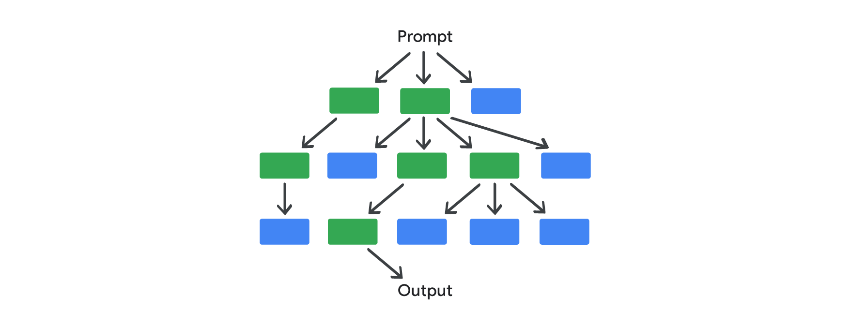The chart begins with a bubble labeled "Prompt" at the top, branching off to three sub-prompts beneath it, with unsuccessful options represented by blue boxes and possibly successful options in green. At center, a green possibly-successful sub-prompt box branches off to four more in the next row down. Those branch off to another row, and in that row, a green box branches down once more to a successful output.
Returning to the earlier example, imagine you're generating a cover image for your course. With tree-of-thought prompting, you might input a prompt similar to this:
Imagine three different designers are pitching their design to me.
All designers will write down one step of their thinking, then share it with the group. Then all experts will go on to the next step, etc. If any expert realizes they're wrong at any point, then they leave.
The question is: Generate an image that's visually energetic, and features images of art supplies and computers. Show me three suggestions in very different styles from simple to detailed and complex.
The AI tool will generate three different styles of images featuring computers and art supplies: one cartoonish, and the other two more photorealistic.

Note: These images are AI-generated. Results are for illustrative purposes and may vary
With multiple options to choose from, you decide that a cartoonish style is best for the cover image, so you continue prompting the tool to create variations of that style.

Note: These images are AI-generated. Results are for illustrative purposes and may vary
And you continue this process, exploring different branches of the tree until you find the perfect fit! If at any point you're dissatisfied with the output, you simply ask the tool to return to a previous branch of the conversation and explore other designs.
In some cases, combining tree-of-thought with chain-of-thought can give your prompting the boost it needs. When you need insight on a tool’s reasoning and other options to take within that reasoning, the two techniques can work perfectly together.
Be mindful, however, that advanced prompt chaining may work differently in various gen AI models. Some more advanced AI models, for example, will automatically detect opportunities for chain-of-thought or tree-of-thought reasoning without being specifically instructed to do so. In those situations, experimentation confirms the best results; repeat your prompt with various models and compare their outputs.
Prompt chaining makes difficult projects easier by dividing a large task into simpler, sequential prompts. But remember, this process still needs a human’s critical thinking skills to work best. With your guidance, prompt chaining can help you evaluate, direct, and correct your prompting process, so you can meet your deadlines with ease.
- Human-in-the-Loop:
The human-in-the-loop approach emphasizes the necessity of human oversight in the generative AI process, ensuring critical evaluation and direction of AI outputs.
- Tree-of-Thought Prompting:
Tree-of-thought prompting allows users to explore multiple potential solutions simultaneously, generating various responses to a prompt and evaluating them to find the most effective approach.
- Chain-of-Thought Prompting:
Chain-of-thought prompting involves asking the AI to explain its reasoning step by step, which helps in understanding how it arrived at a particular output and can guide adjustments to prompts.
- Prompt Chaining:
Prompt chaining is the process of connecting multiple prompts in a sequence, where the output of one prompt serves as the context for the next, allowing for more complex task management.

